Admin Portal User Guide
This document provides a step-by-step overview of the Admin Portal and explains how administrators can use the system to manage organizations, participants, question categories, tags, questions, templates, and workshop scheduling. Each section below is supported by screenshots to make the workflow easier to understand and follow.
1. Admin Login Page
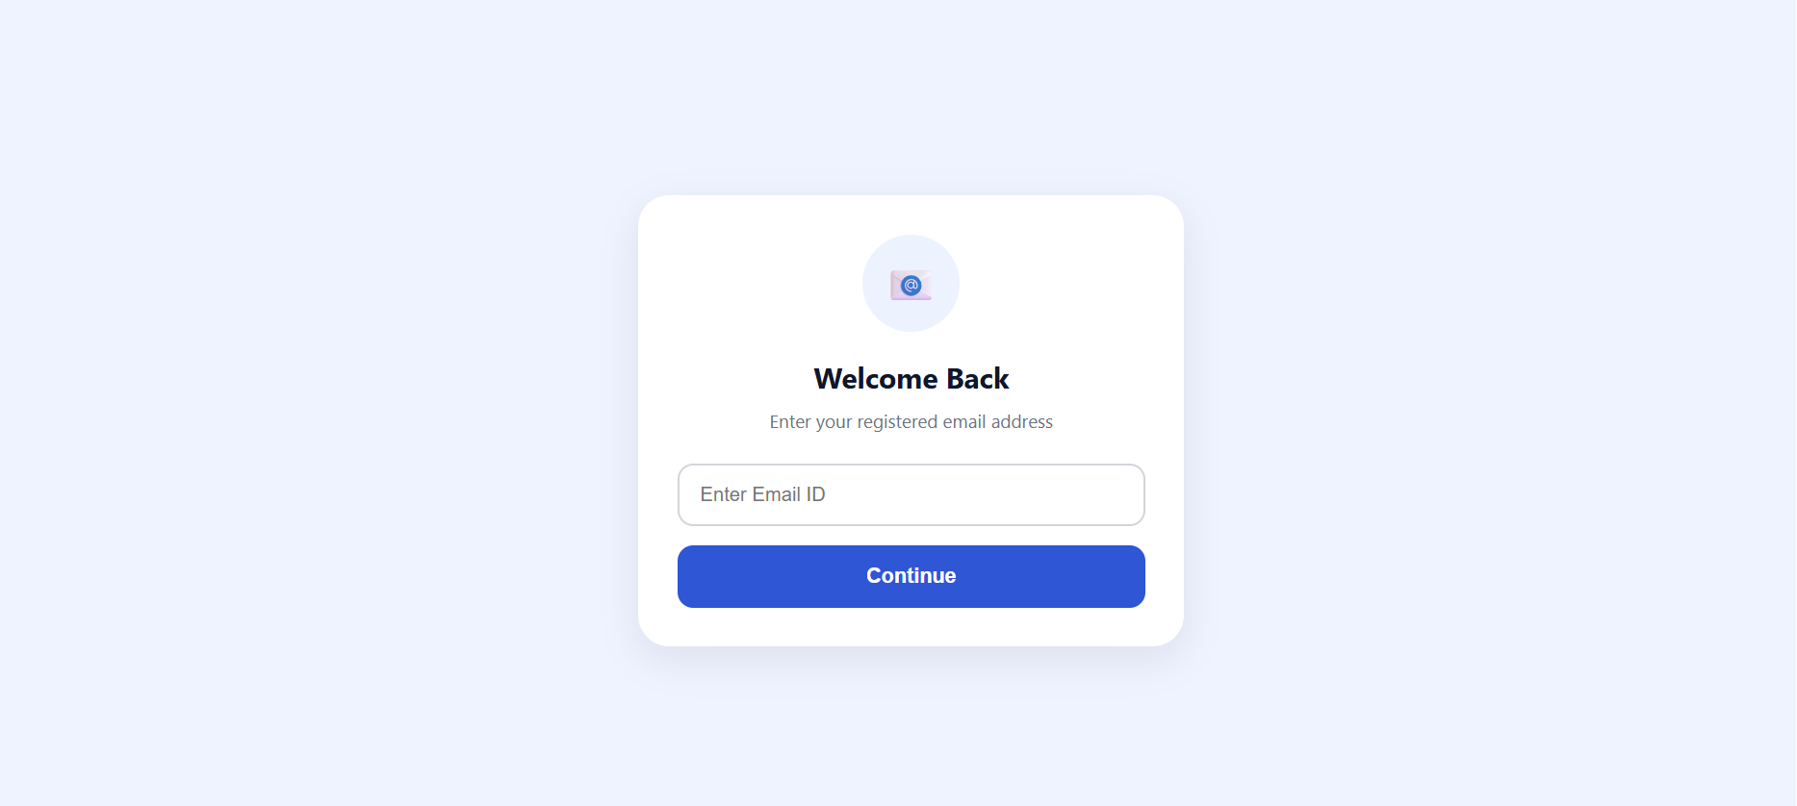
This screen is the entry point to the Admin Portal.

2. Dashboard Overview
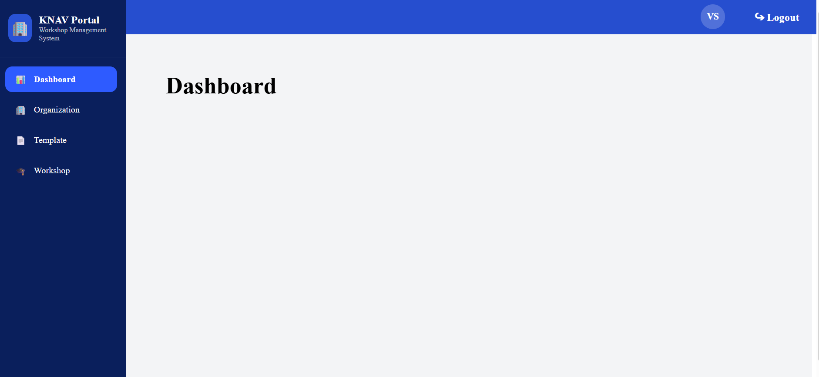
The dashboard serves as the main control panel for administrators. From this page, users can view the portal’s major modules, monitor available records, and navigate important administrative tasks such as managing organizations, participants, question categories, tags, questions, templates, and workshop schedules.

3. Organization and Participant Management
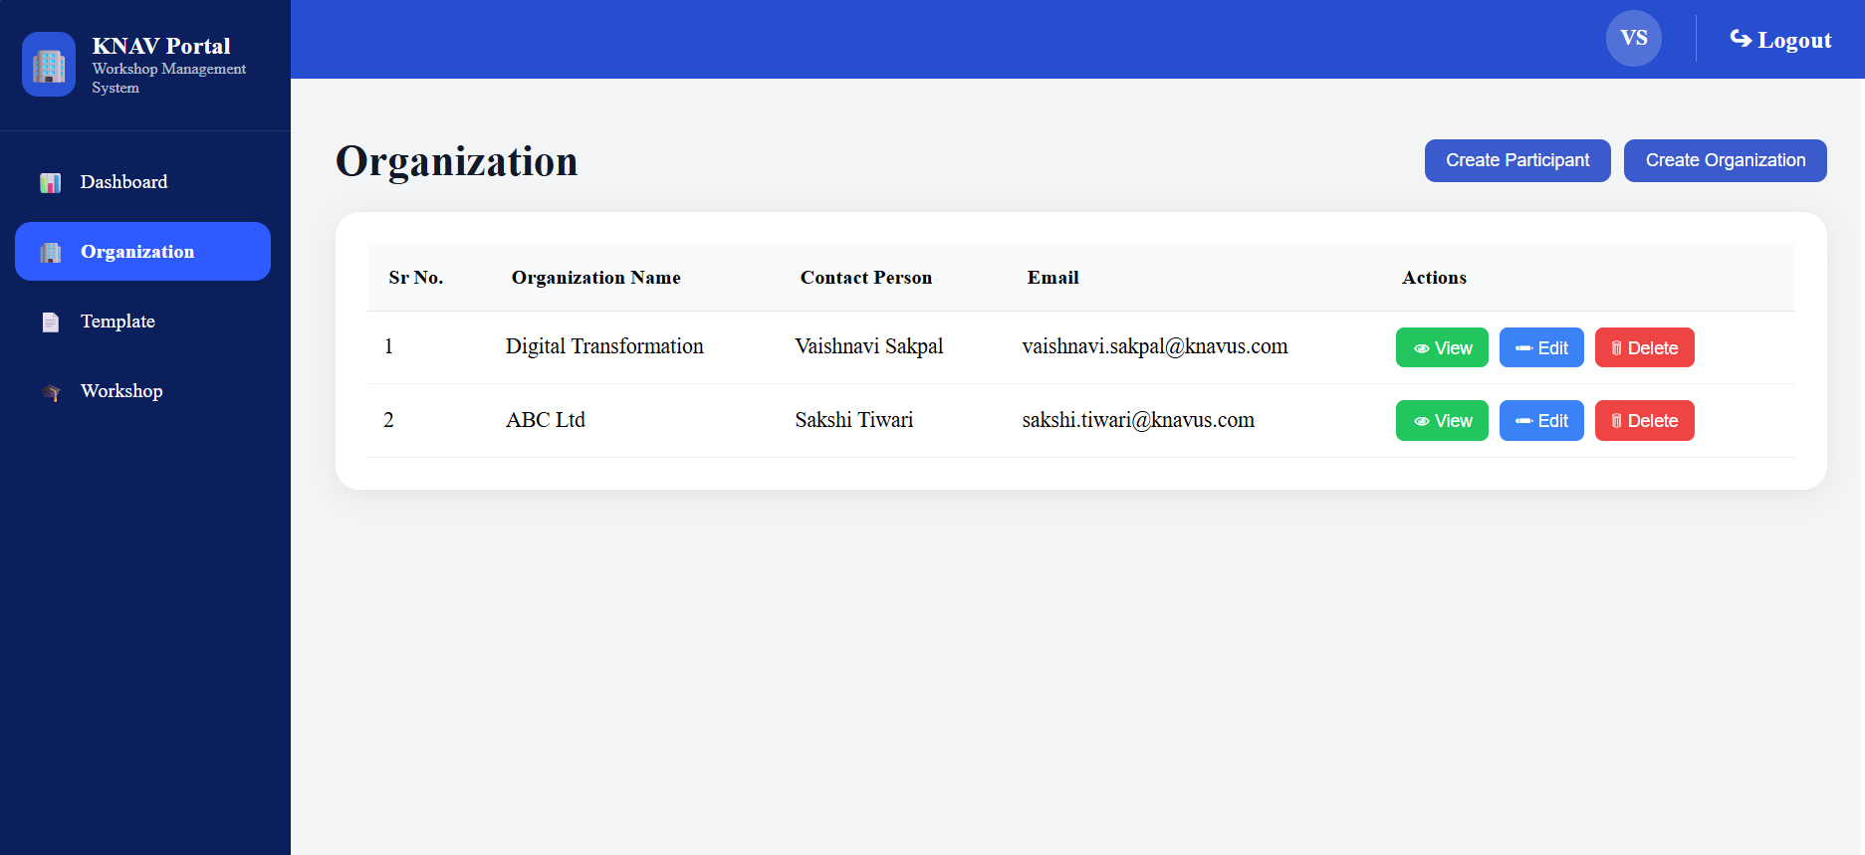

To create a new organization, navigate to the Organization section and click Create Organization. This action opens the organization creation workflow, where the administrator can register a new organization in the system.

A pop-up form appears for entering the required organization details. Fill in all necessary information accurately, review the entries, and then click Save to complete the organization creation process. Once saved successfully, the organization becomes available for future administrative activities such as assigning participants and scheduling workshops.
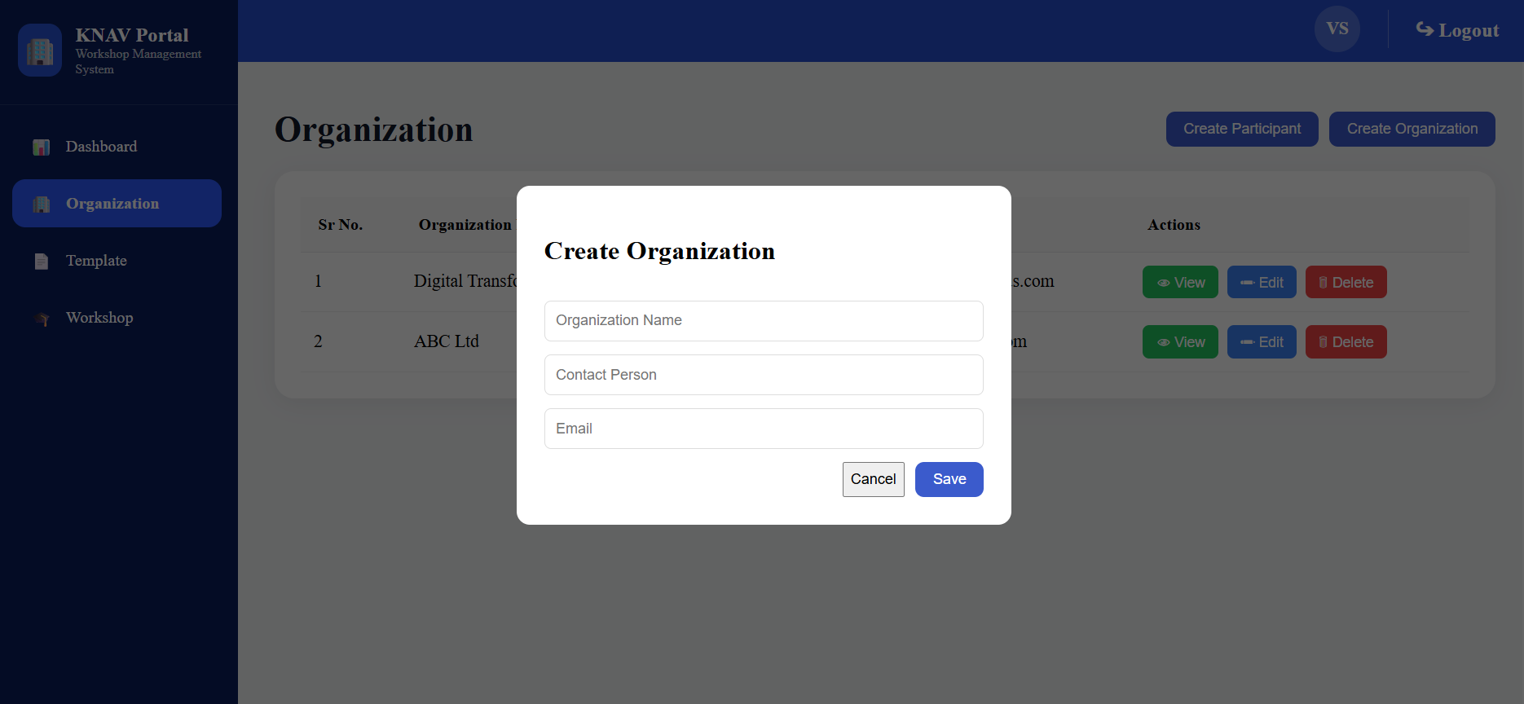

After the organization is created successfully, it is displayed in the Organization tab.
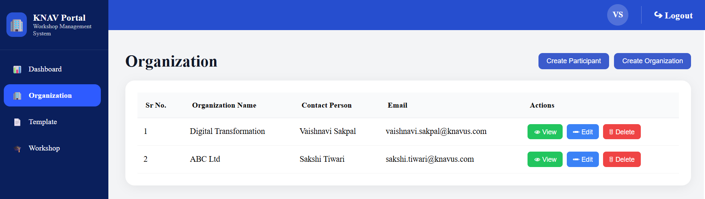

To add participants, click Create Participants, enter the required participant information, and save the details.
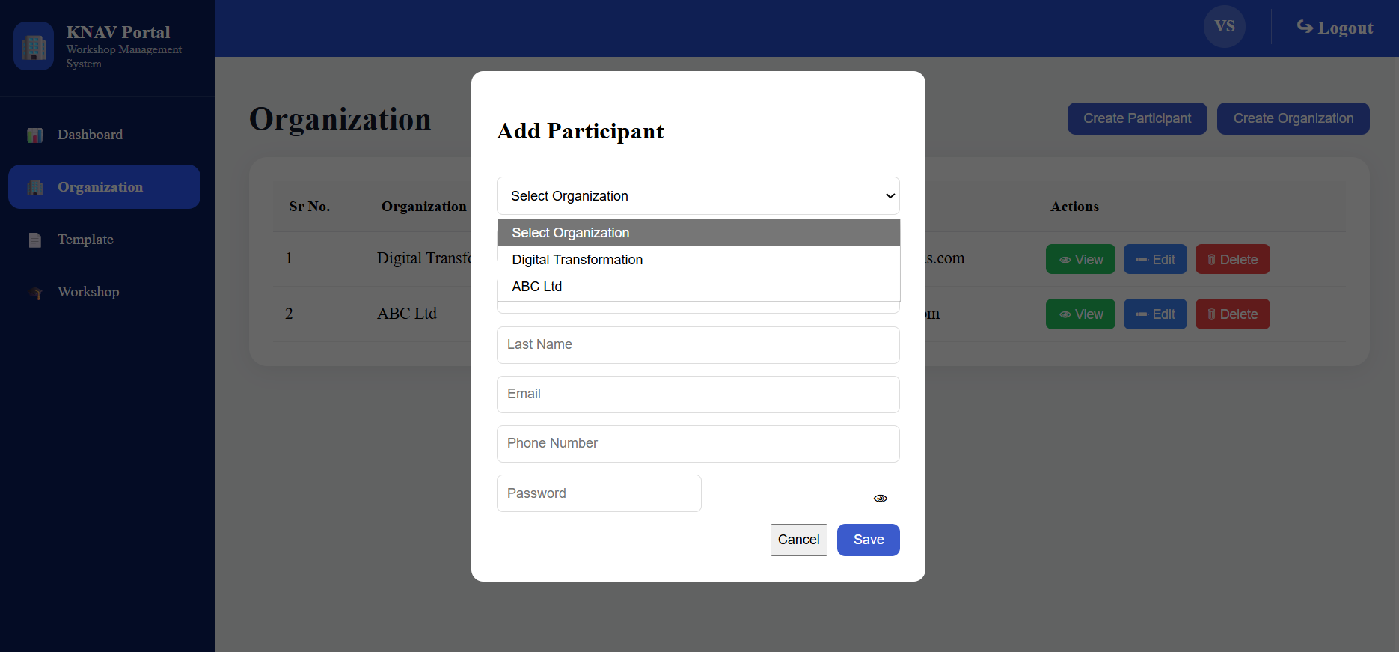

4. Question Category Management
In this section, administrators can create and manage question categories. Click on create question category, enter the required details, and save the information.
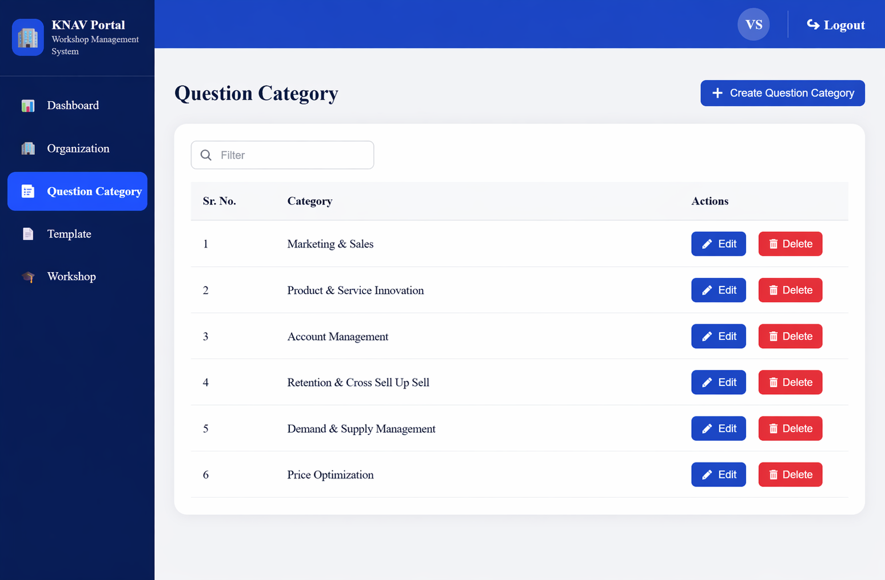

5. Tag Management
Admin can create tags to further classify and group questions. Click the Create Tag button, provide the relevant tag details, and save the record.
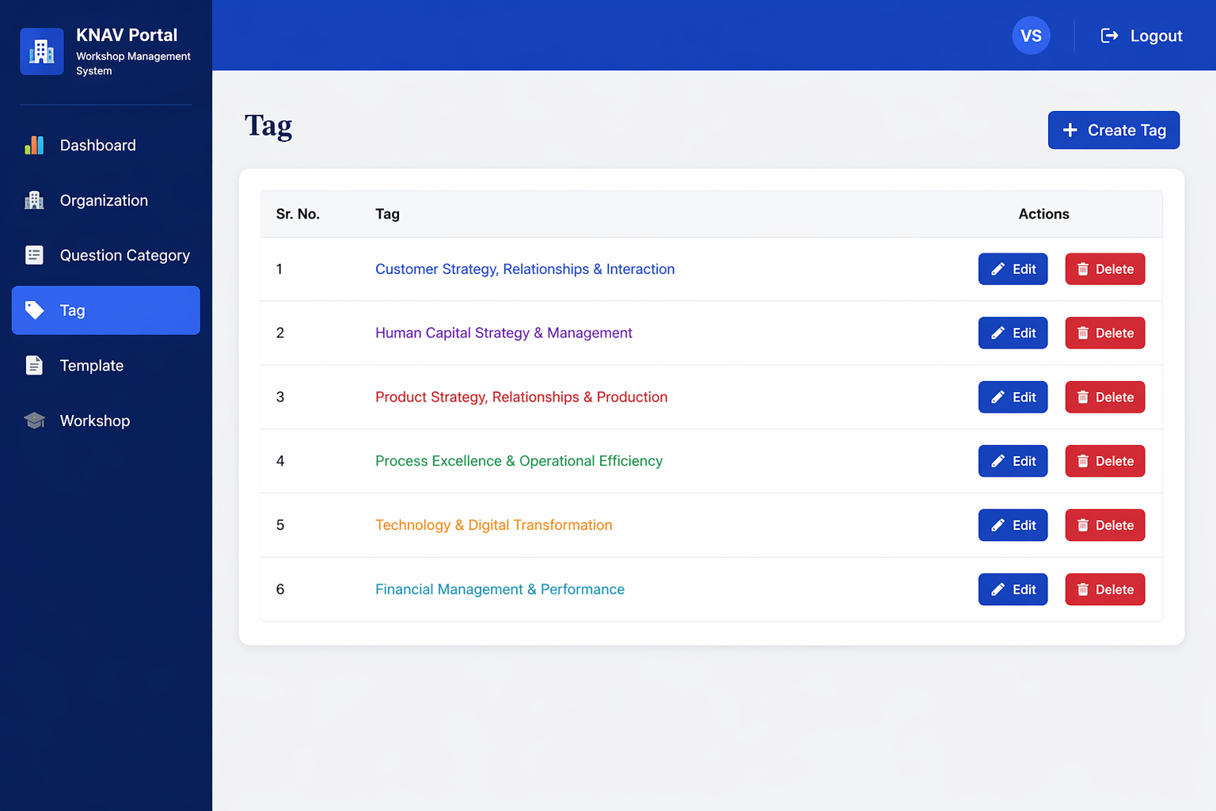

6. Question Creation
Questions can be added by selecting the appropriate question category and applying the relevant tags.
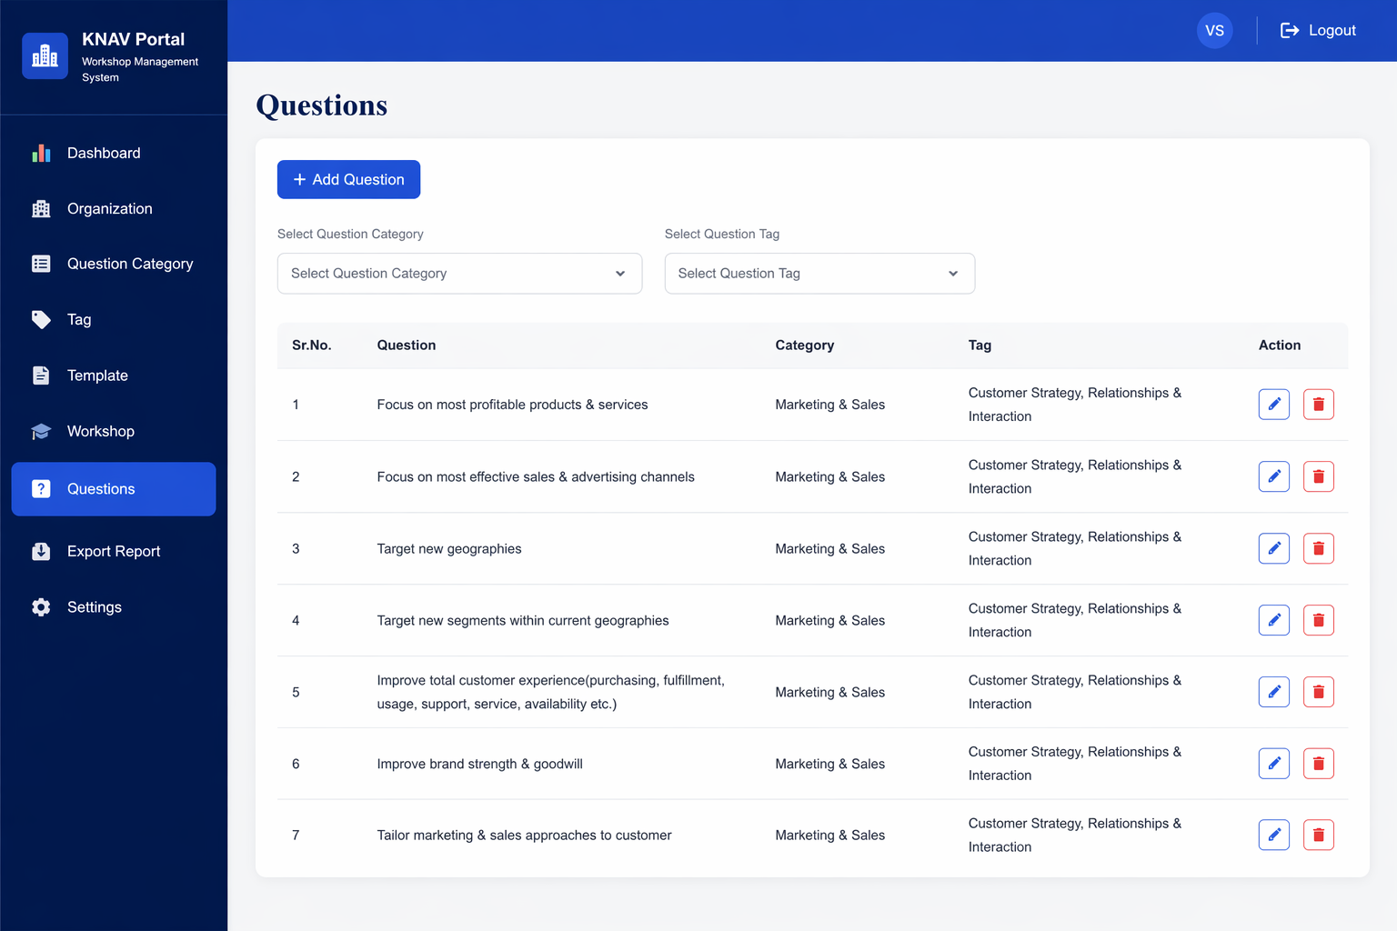

7. Template Management
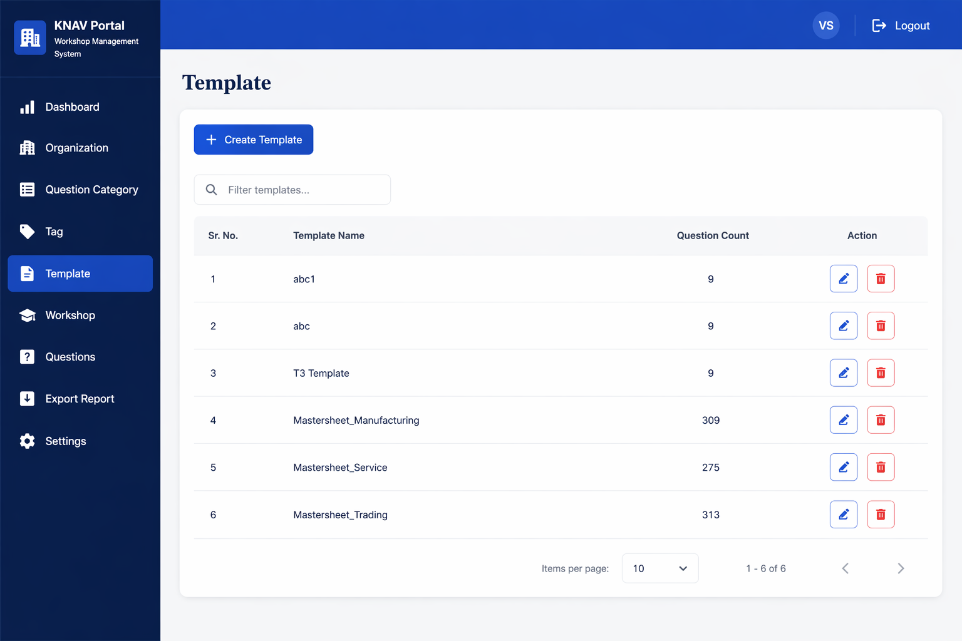
The Template tab is used to create structured questionnaire templates. To create a template, select the required questions and add them to the template.
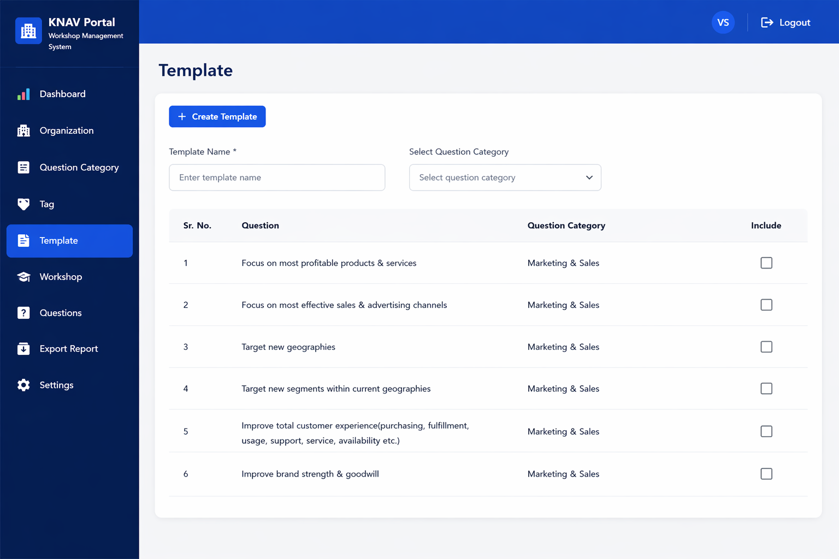

8. Workshop Scheduling
After creating both the organization and the template, the next step is to schedule a workshop. During this process, the admin selects the relevant organization and assigns the appropriate template.
